ASSIGNMENT – 6.2
DAVUPATI PREETHI
2303A52378
Batch – 37
Task Description-1 (Classes – Data Validation)
• Prompt AI to generate a Student class with attributes: name,
roll_no, and marks. Add a method is_pass() that returns whether
the student has passed (marks ≥ 40).
Expected Output-1
• Python class with constructor and validation logic
• Clear method implementation returning pass/fail status
• Students analyze correctness and clarity of class design
PROMPT:
Generate a Student class with attributes: name, roll_no, and marks. Add a method is_pass() that returns whether the student has passed (marks ≥ 40)
CODE:
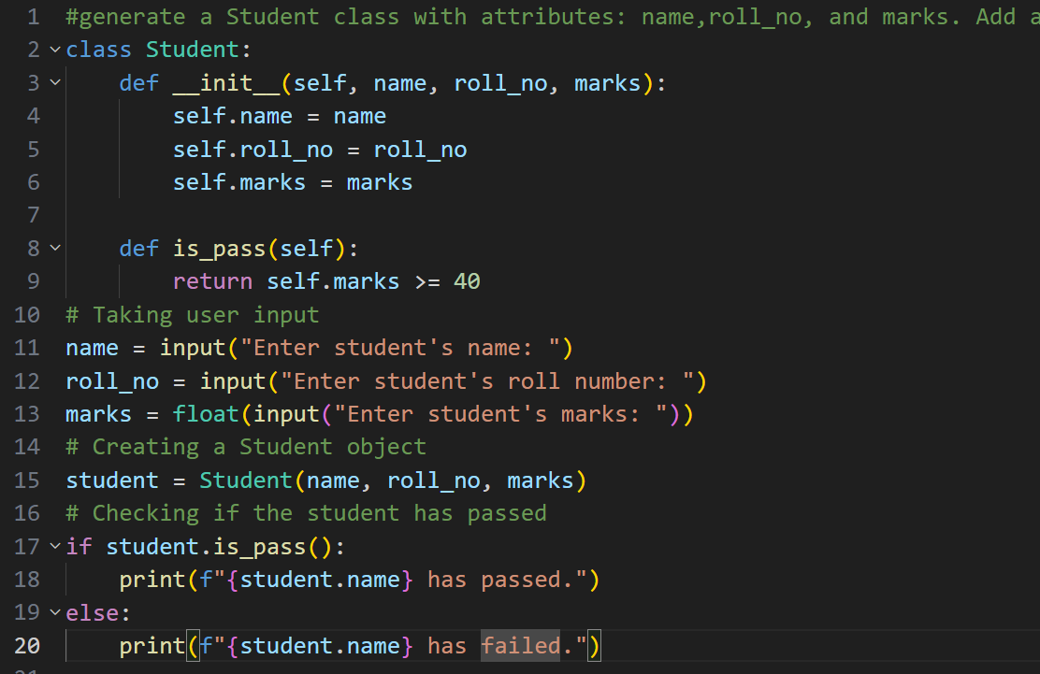

OUTPUT:
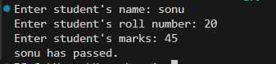
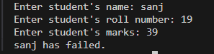
EXPLANATION:
This program creates a Student class to store a student’s name, roll number, and marks. The constructor saves these details when the object is created. The is_pass() method checks if the marks are 40 or more to decide pass or fail. The program takes input from the user and shows the result.
Task Description-2 (Loops – Pattern Generation)
• Ask AI to generate a function that prints a right-angled triangle
star pattern using a for loop. Then regenerate the same pattern
using a while loop.
Expected Output-2
• Correct pattern output using both loop types
• Logical loop structure with proper condition
PROMPT:
generate a function that prints a right-angled triangle star pattern using a for loop
CODE:
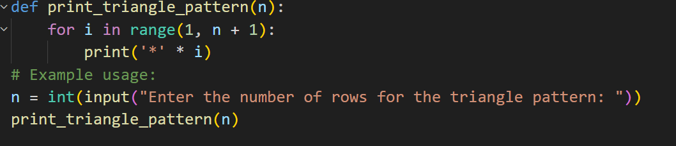
OUTPUT:
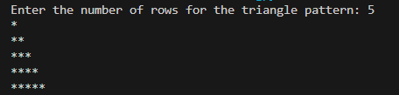
PROMPT:
generate a function that prints a right-angled triangle star pattern using a while loop
CODE:
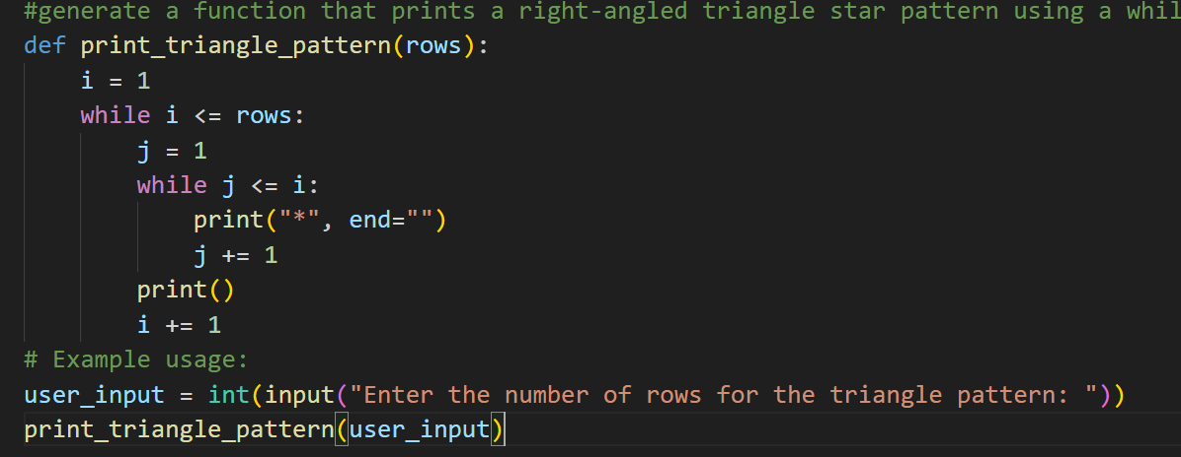
OUTPUT:
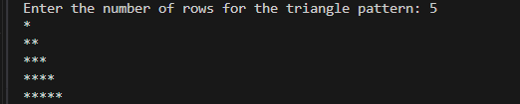
EXPLANATION:
These two programs print a right-angled triangle star pattern. The first program uses a for loop where the number of stars printed in each line increases with every loop iteration. The second program uses while loops to achieve the same result by controlling the number of rows and stars using conditions. Both programs produce the same output but use different looping methods.
Task Description-3 (Conditional Statements – Number Analysis)
• Ask AI to write a function that checks whether a given number
is positive, negative, or zero using if-elif-else. Test the function
with multiple inputs.
Expected Output-3
• Function correctly classifies numbers
• Proper handling of all conditions
• Students analyze decision logic
PROMPT:
Write a function that checks whether a given number is positive, negative, or zero using if-elif-else

CODE:
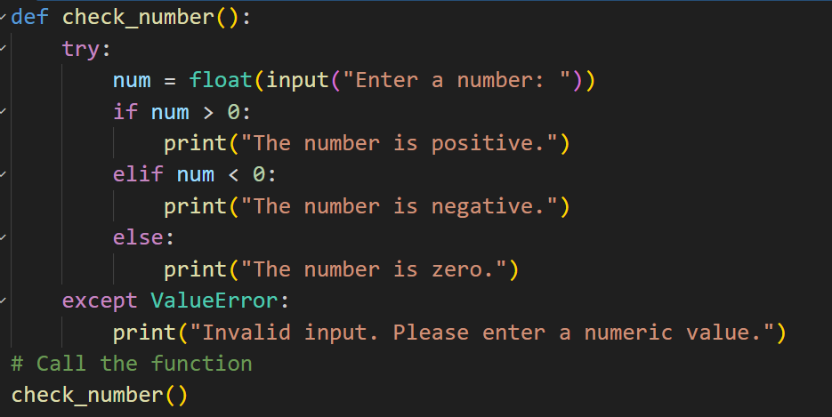
OUTPUT:

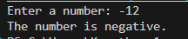
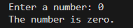
EXPLANATION:
This program asks the user to enter a number and checks whether it is positive, negative, or zero. It prints the result using if-elif-else. If the user enters something that is not a number, it shows an error message.
Task Description-4 (Nested Conditionals)
• Generate a function check_discount(age, is_member) that
determines discount eligibility:
• Age ≥ 60 → Senior discount
• Member → Additional discount
Use nested if statements.
Expected Output-4
• Python code using nested conditionals
• Clear explanation of decision flow

PROMPT:
Generate a function check_discount(age, is_member) that determines discount eligibility:
• Age ≥ 60 → Senior discount
• Member → Additional discount
Use nested if statements
CODE
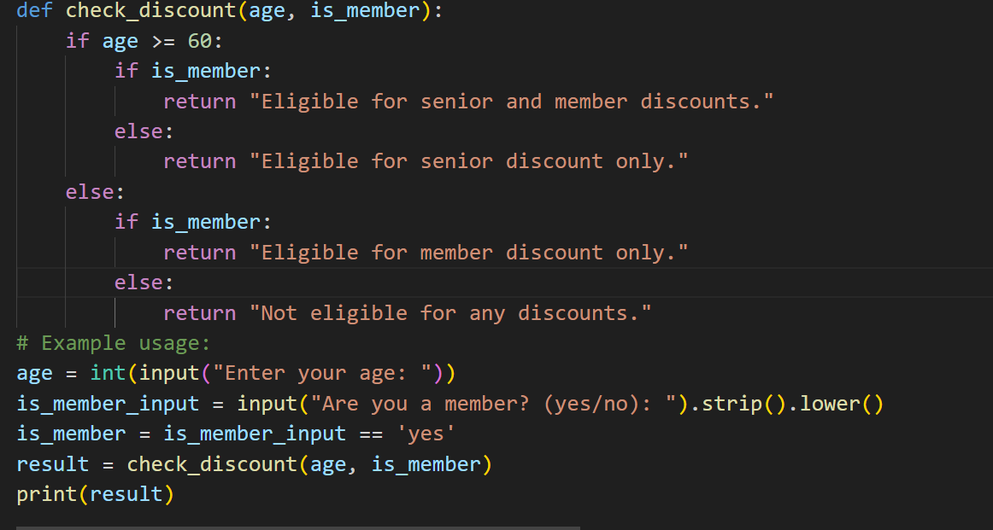
OUTPUT:
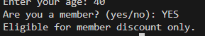
EXPLANATION:
This program checks discounts using age and membership. If the person is 60 or older, they get a senior discount. If they are also a member, they get both discounts. If they are under 60, only members get a discount. If none of these apply, no discount is given.
Task Description-5 (Class – Mathematical Opera)
• Ask AI to create a Circle class with methods to calculate area ()
and circumference () given the radius.
Expected Output-5
• Correct mathematical computation
• Well-structured class with methods
• Code explanation provided

PROMPT:
create a Circle class with methods to calculate area () and circumference () given the radius
CODE:
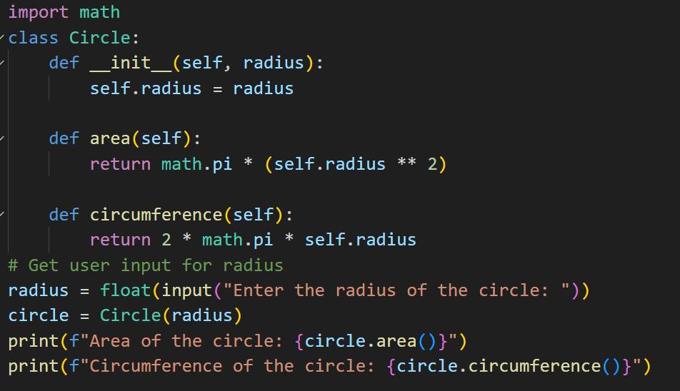
OUTPUT:
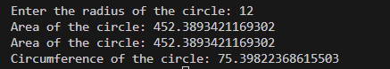
EXPLANATION:
This program creates a Circle class that stores the radius of a circle. It uses one method to find the area and another method to find the circumference. The radius is taken from the user, and the results are printed.

